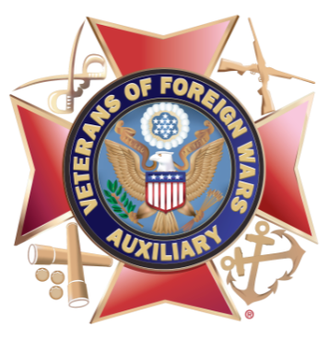
HAPPY TO BIRTHDAY THE AUXILIARY TO THE VETERANS OF FOREIGN WARS
On this day in 1914, the Ladies Auxiliary to the Veterans of Foreign Wars was organized in Pittsburgh, Pennsylvania. Our name has since changed to the Veterans of Foreign Wars Auxiliary and our eligibility includes close male relatives of those who served in overseas combat.
We are thankful for the millions (yes, millions!!!) of members who have served veterans, active-duty military and their families, and spread patriotism across communities throughout our great nation during our first 103 years.
We've accomplished a lot since 1914. Here's a snapshot:
1917 – Members help drive sales of Liberty Bonds nationwide.
1931 – The Star Spangled Banner becomes the National Anthem.
1933 – Members join VFW in pushing for “Bonus Bill.”
1938 – Auxiliary chaired the Women’s Patriotic Conference.
1942 – Veterans Affairs Voluntary Service is organized; Auxiliary is charter member.
1944 – Auxiliary gains national publicity for the “Keep ‘em Smiling” letter-writing poster campaign.
1950 – Sponsorship of Operation Freedom, a post-war student exchange program.
1953 – Auxiliary produces radio history show "The American Trail," which was nominated for an Emmy.
1965 – First Unsung Heroine award is presented.
1979 – Young American Creative Patriotic Art Contest is started.
1986 – Statue of Liberty turns 100; Auxiliary donates $221,000 for restoration.
1993 – Auxiliary sponsors $3.4 million in renovations of the National Home’s Community Center.
2011 – Auxiliary launches national Military Suicide Awareness campaign.
AND THE LIST GOES ON THROUGH 2022!

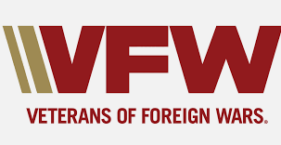
NATIONAL VFW DAY
The Veterans of Foreign Wars of the United States (V.F.W.) organization was created in 1913. During a historic convention in Pittsburgh. The organization was formed through a merger of three war-veteran associations, which had been founded in 1899 after the Spanish-American War. The American Veterans of Foreign Service, which had two chapters, was based in Ohio and Pennsylvania while The Colorado Society of the Army of the Philippines was located in Colorado and Pennsylvania.
The VFW was established on September 29, 1899, by a group of veterans from the Spanish-American War and the Philippine Insurrection. It has since grown to be the nation’s largest group of combat veterans. They continue “to honor the dead by helping the living.” The VFW promotes patriotism, goodwill, and youth scholarships. They also provide military assistance and community service programs, promote youth activities, and volunteer many hours in their local communities.
The men who founded the VFW challenged the status quo and helped to forever change how our nation cares for her veterans, service members and their families. Virtually every military and veteran quality of life program created in this century and last is due to the tenacity and perseverance of VFW members to ensure that a nation that creates veterans properly takes care of them when they return home.

